

Nama : Grandies Silvania Verdianto

Kelas : R1

NIM : 210511003

1. Hierarchical1

# Nama  : Grandies Silvania Verdianto

# Kelas : R1

# NIM   : 210511003

class Employee:

    def __init__(self, name, salary):

        self.name = name

        self.salary = salary

    def display_info(self):

        print("Name:", self.name)

        print("Salary:", self.salary)

class Manager(Employee):

    def __init__(self, name, salary, department):

        super().__init__(name, salary)

        self.department = department

    def display_info(self):

        super().display_info()

        print("Department:", self.department)

class Engineer(Employee):

    def __init__(self, name, salary, skill):

        super().__init__(name, salary)

        self.skill = skill

    def display_info(self):

        super().display_info()

        print("Skill:", self.skill)

employee1 = Employee("Son", 5000)

manager1 = Manager("Chanwook", 7000, "Marketing")

engineer1 = Engineer("Rommy", 6000, "Python")

employee1.display_info()

manager1.display_info()

engineer1.display_info()

engineer1.display_info()

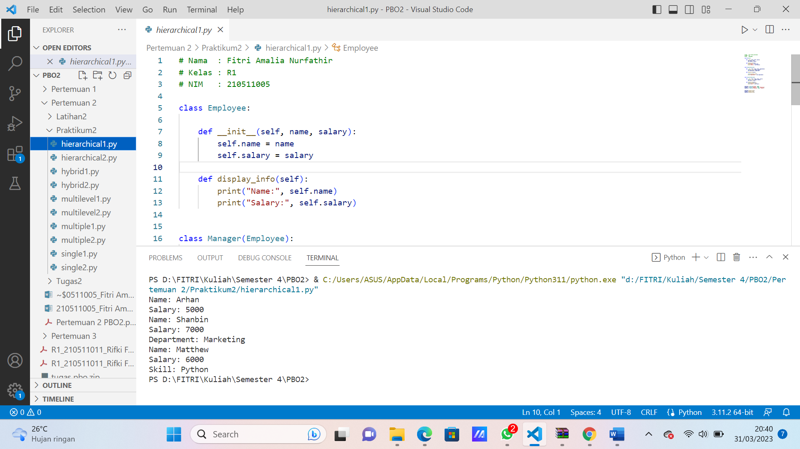

1. Hierarchical2

# Nama  : Grandies Silvania Verdianto

# Kelas : R1

# NIM   : 210511003

class Vehicle:

    def __init__(self, brand, model):

        self.brand = brand

        self.model = model

    def info(self):

        print(f"This is a {self.brand} {self.model}")

class Car(Vehicle):

    def __init__(self, brand, model, num_of_doors):

        super().__init__(brand, model)

        self.num_of_doors = num_of_doors

    def info(self):

        super().info()

        print(f"It has {self.num_of_doors} doors")

my_car = Car("Honda", "Jazz", 4)

my_car.info()

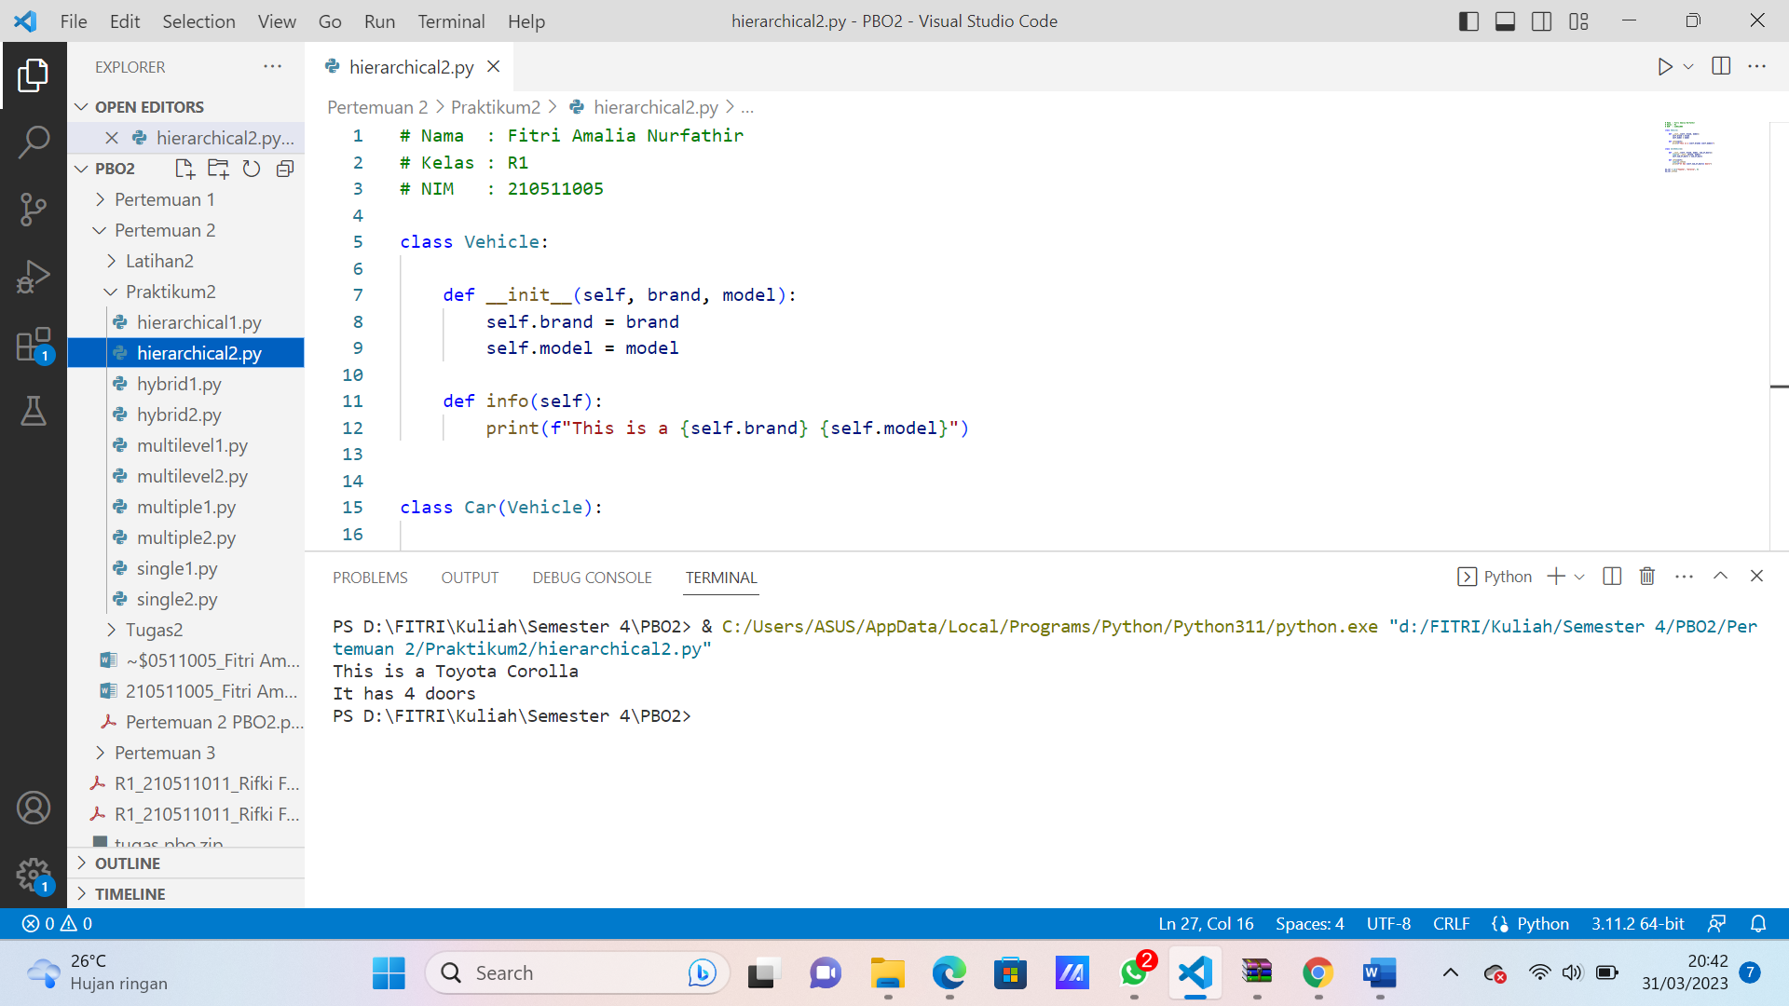

1. Hybrid1

# Nama  : Grandies Silvania Verdianto

# Kelas : R1

# NIM   : 210511003

class Grup:

    def __init__(self, Nama, Usia):

        self.Nama = Nama

        self.Usia = Usia

    def Info(self):

        print("Identitas\nNama: ",self.Nama)

        print("Usia: ", self.Usia)

class Membership(Grup):

    def __init__(self, Nama, Usia, Status):

        super().__init__(Nama, Usia)

        self.Status = Status

    def Info(self):

        super().Info()

        print("Status: ",self.Status)

class Member(Grup):

    def __init__(self, Nama, Usia, Jenis_Membership):

        super().__init__(Nama, Usia, Jenis_Membership)

        self.Jenis_Membership = Jenis_Membership

    def Info(self):

        super().Info()

        print("Jenis_Membership: ", self.Jenis_Membership)

class Orang(Member, Membership):

    def __init__(self, Nama, Usia, Status, Jenis_Membership, Alamat):

        Member.__init__(self, Nama, Usia, Jenis_Membership)

        Membership.__init__(self, Nama, Usia, Status)

        self.Alamat = Alamat

    def Info(self):

        super().Info()

        print("Alamat: ",self.Alamat)

orang = Orang("Grandies Silvania Verdianto", "20", "Aktif", "Platinum", "Sumber")

orang.Info()

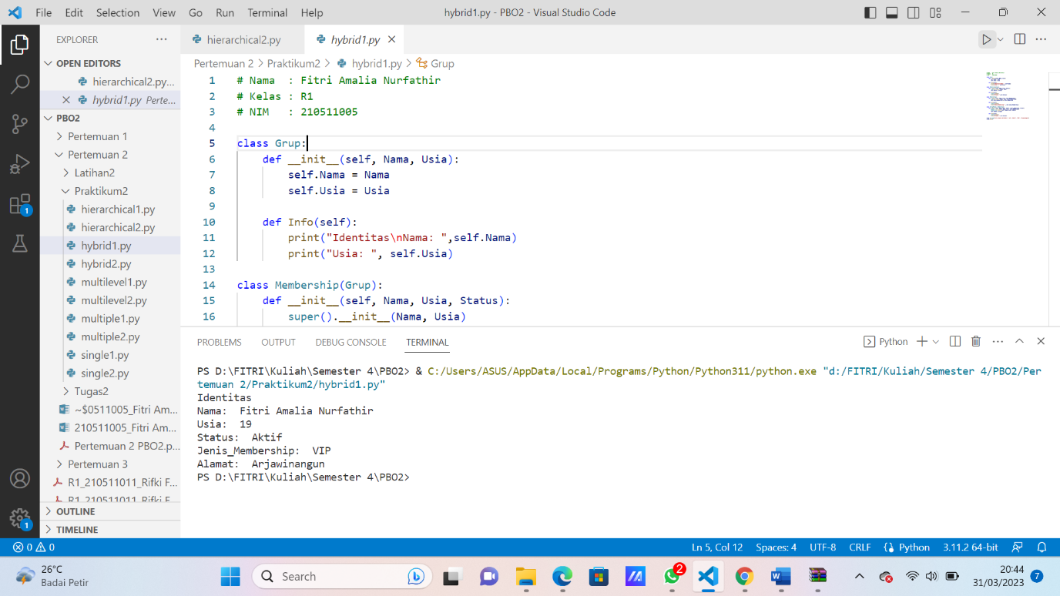

1. Hybrid2

# Nama  : Grandies Silvania Verdianto

# Kelas : R1

# NIM   : 210511003

class Animal:

    def __init__(self, name):

        self.name = name

    def speak(self):

        pass

class Mammal(Animal):

    def __init__(self, name):

        super().__init__(name)

    def give_birth(self):

        pass

class Dog(Mammal):

    def __init__(self, name, breed):

        super().__init__(name)

        self.breed = breed

    def speak(self):

        return "Woof"

class Cat(Mammal):

    def __init__(self, name, breed):

        super().__init__(name)

        self.breed = breed

    def speak(self):

        return "Meow"

class Poodle(Dog):

    def __init__(self, name, breed, size):

        super().__init__(name, breed)

        self.size = size

my_dog = Poodle("Rocky", "Poodle", "Big")

print(my_dog.name)

print(my_dog.breed)

print(my_dog.size)

print(my_dog.speak())

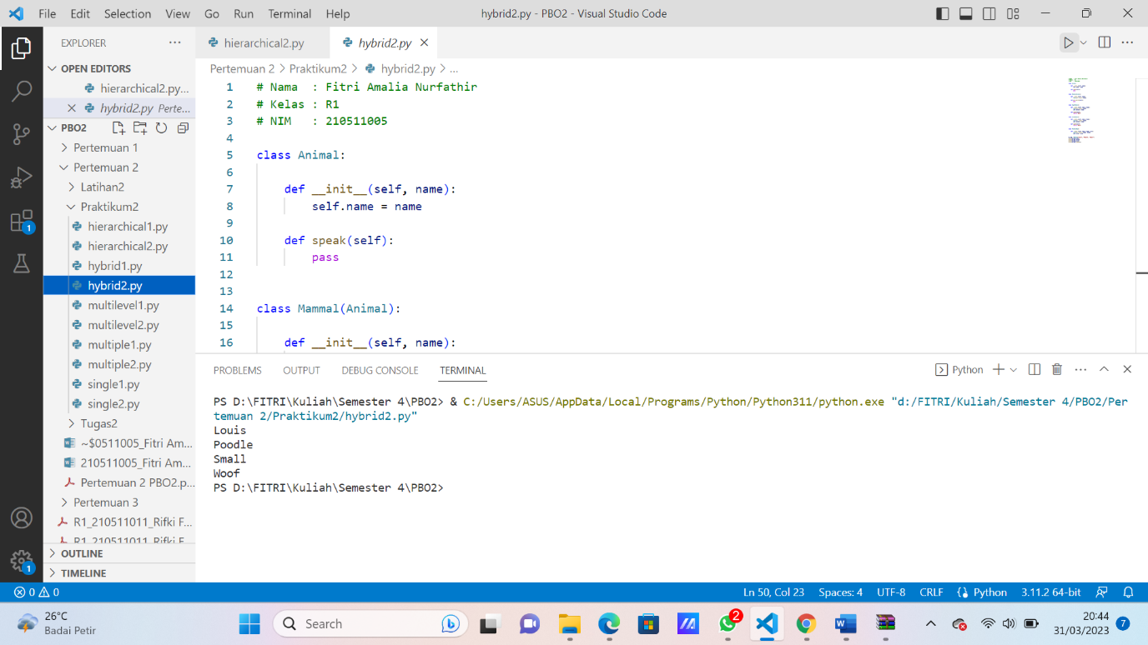

1. Multilevel1

# Nama  : Grandies Silvania Verdianto

# Kelas : R1

# NIM   : 210511003

class Animal:

    def __init__(self, name):

        self.name = name

    def speak(self):

        print(f"{self.name} speaks")

class Bird(Animal):

    def __init__(self, name, wingspan):

        super().__init__(name)

        self.wingspan = wingspan

    def fly(self):

        print(f"{self.name} is flying with a wingspan of {self.wingspan}")

class Parrot(Bird):

    def __init__(self, name, wingspan, color):

        super().__init__(name, wingspan)

        self.color = color

    def speak(self):

        print(f"{self.name} is a {self.color} parrot that talks")

parrot = Parrot("Jarot", 12, "black")

parrot.speak()

parrot.fly()

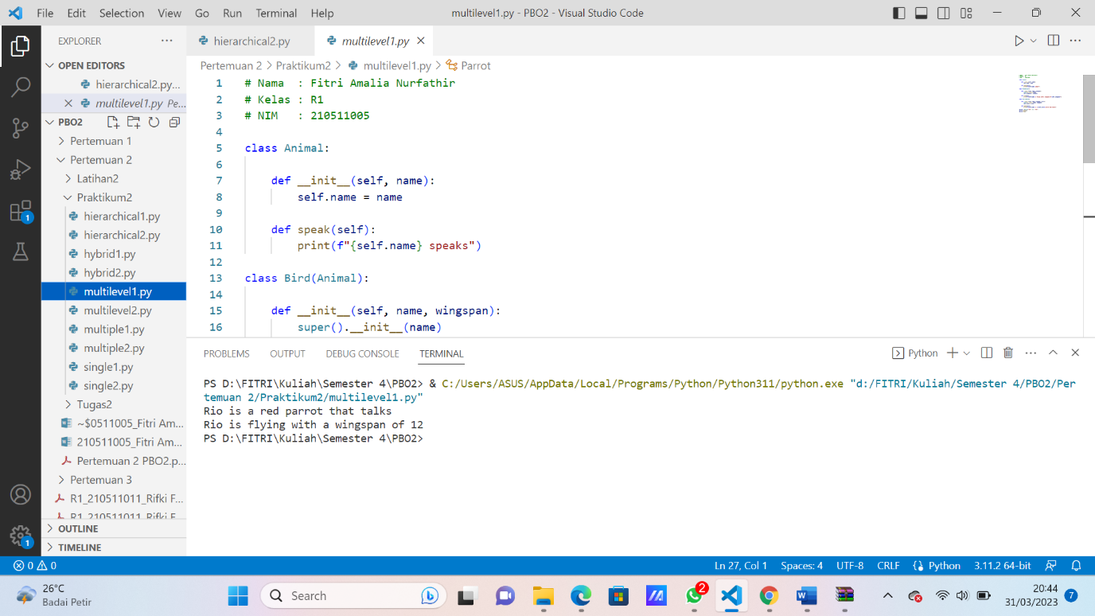

1. Multilevel2

# Nama  : Grandies Silvania Verdianto

# Kelas : R1

# NIM   : 210511003

class Buah:

    def __init__(self, name):

        self.name = name

    def Rasa(self):

        print("Buah-buahan memiliki banyak manfaat")

class Mangga(Buah):

    def __init__(self, name, rasa):

        super().__init__(name)

        self.rasa = rasa

    def Rasa(self):

        print("Mangga mengandung vitamin A")

class ManggaCengkir(Mangga):

    def __init__(self, name, rasa, asal):

        super().__init__(name, rasa)

        self.asal = asal

    def Rasa(self):

        print("Mangga Cengkir memiliki rasa yang manis")

ManggaCengkirA = ManggaCengkir("Mangga Cengkir"," manis", "Indonesia")

ManggaB = Mangga("Mangga", "Manis")

buahC = Buah("Buah apa yang enak?")

ManggaCengkirA.Rasa()

ManggaB.Rasa()

buahC.Rasa()

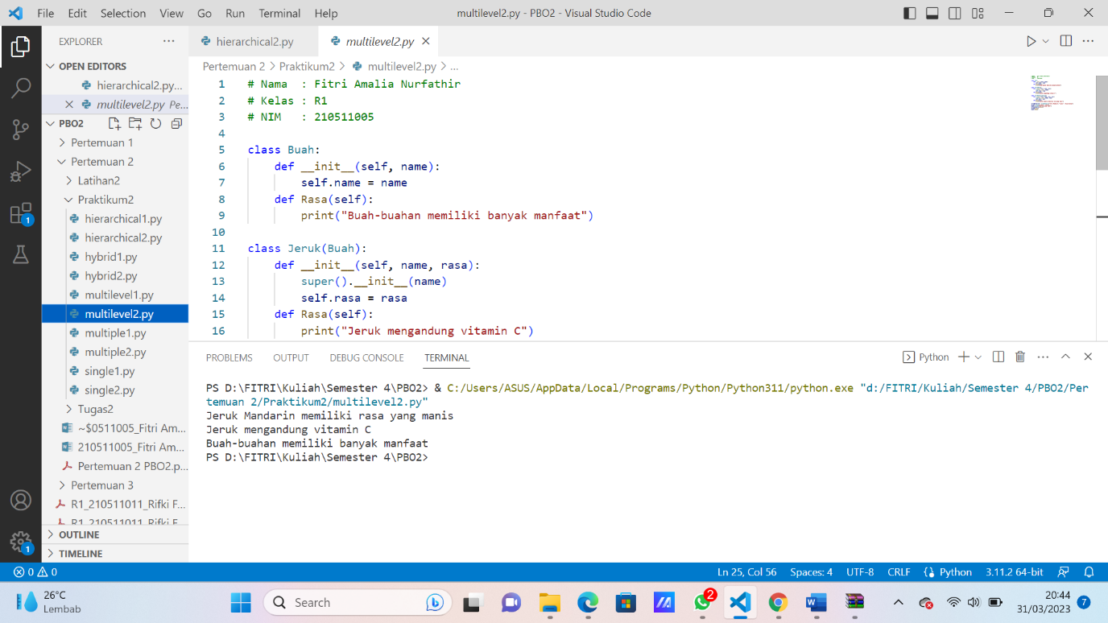

1. Multiple1

# Nama  : Grandies Silvania Verdianto

# Kelas : R1

# NIM   : 210511003

class Customer:

    def __init__(self, nama, nim):

        self.nama = nama

        self.nim = nim

    def membeli(self):

        print(self.nama, "sedang membeli paket di aplikasi Oren ")

class Kurir:

    def __init__(self, nama, nim, kurir):

        self.nama = nama

        self.nim = nim

        self.kurir = kurir

    def mengantar(self):

        print(self.nama, "sedang mengantar paket ke kurir", self.kurir)

class CustomerKurir(Customer, Kurir):

    def __init__(self, nama, nim, kurir):

        Customer.__init__(self, nama, nim)

        Kurir.__init__(self, nama, nim, kurir)

    def membayar(self):

        print(self.nama,"dengan NIM", self.nim, "sedang membayar paket ke kurir", self.kurir)

mhs_kurir = CustomerKurir("Grandies Silvania Verdianto", "210511003", "SiCepat")

mhs_kurir.membeli()

mhs_kurir.mengantar()

mhs_kurir.membayar()

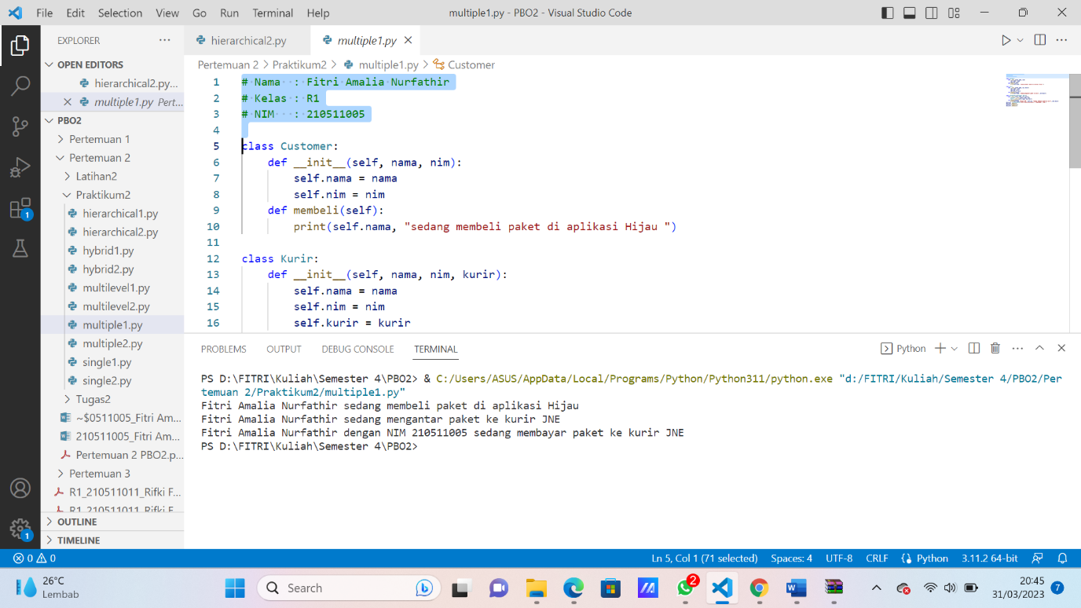

1. Multiple2

# Nama  : Grandies Silvania Verdianto

# Kelas : R1

# NIM   : 210511003

class Hewan:

    def __init__(self, jenis):

        self.jenis = jenis

    def display_info(self):

        print(f"Jenis hewan: {self.jenis}")

class Mamalia(Hewan):

    def __init__(self, nama):

        self.nama = nama

    def display_info(self):

        super().display_info()

        print(f"Nama hewan: {self.nama}")

class Herbivora(Hewan):

    def __init__(self, jenis, makanan):

        super().__init__(jenis)

        self.makanan = makanan

    def display_info(self):

        super().display_info()

        print(f"Jenis makanan: {self.makanan}")

class Kangguru(Mamalia, Herbivora):

    def __init__(self, jenis, nama, makanan):

        Mamalia.__init__(self, nama)

        Herbivora.__init__(self, jenis, makanan)

    def display_info(self):

        super().display_info()

        print(f"Jenis hewan: {self.jenis}")

# contoh penggunaan

kangguruA = Kangguru("Mamalia", "Sapi", "Rerumputan")

kangguruA.display_info()

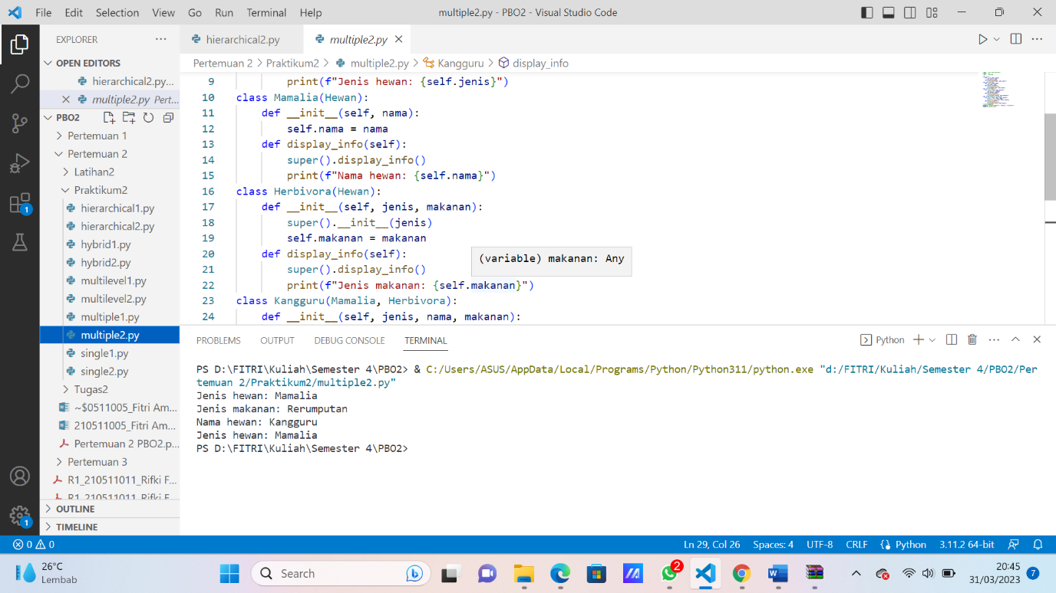

1. Single1

# Nama  : Grandies Silvania Verdianto

# Kelas : R1

# NIM   : 210511003

class Hewan:

    def __init__(self, nama, umur):

        self.nama = nama

        self.umur = umur

    def bergerak(self):

        print(self.nama, "bergerak")

class Kucing(Hewan):

    def __init__(self, nama, umur, jenis_bulu):

        super().__init__(nama, umur)

        self.jenis_bulu = jenis_bulu

    def bersuara(self):

        print("Meow!")

kucingA = Kucing("Sky", 1, "Persia")

kucingA.bergerak()

kucingA.bersuara()

1. Single2

# Nama  : Grandies Silvania Verdianto

# Kelas : R1

# NIM   : 210511003

class Kendaraan:

    def __init__(self, jenis, merk, warna):

        self.jenis = jenis

        self.merk = merk

        self.warna = warna

    def berkendara(self):

        print("Kendaraan ini sedang berjalan.")

class Mobil(Kendaraan):

    def __init__(self, jenis, merk, warna, cc):

        super().__init__(jenis, merk, warna)

        self.cc = cc

    def belok(self):

        print("Mobil ini sedang belok.")

motorA = Mobil("Mobil", "Minibus", "Hitam", 2000)

motorA.berkendara()

motorA.belok()